# Title:Hate Speech Detection Project Documentation

**Name**: Parneet Kaur

**Mentor**: Dr. N Jagan Mohan

# Introduction

Hate speech detection is a significant application in the field of natural language processing (NLP). It involves automatically identifying offensive or hateful content in text, which can help in moderating online platforms, improving user experience, and fostering a safer digital environment. This project aims to build a model that can accurately detect hate speech and offensive language in social media text.

The project consists of several stages, including data preprocessing, feature extraction, and handling class imbalance in the dataset. Through these steps, the model will learn to differentiate between hate speech, offensive language, and neutral content.

# Dataset Description

The dataset used in this project contains tweets classified into three categories:

* **Hate Speech**: Content that directly promotes hate or violence toward individuals or groups.
* **Offensive Language**: Content that may contain profanities or offensive remarks but does not explicitly incite hate.
* **Neutral**: Content that is neither hateful nor offensive.

The dataset includes the following columns:

* **count**: Represents the number of occurrences or instances.
* **hate_speech_count**: The count of hate speech labels.
* **offensive_language_count**: The count of offensive language labels.
* **neither_count**: The count of neutral labels.
* **class**: Label indicating the type of speech (0: Hate Speech, 1: Offensive Language, 2: Neutral).
* **tweet**: The actual tweet text to be analyzed.

**Example Records from the Dataset**

|  |  |  |  |  |  |  |  |
| --- | --- | --- | --- | --- | --- | --- | --- |
| count | hate_speec h_count | offensive_l anguage_c ount | neither_co unt | class | tweet |  |  |
| 3 | 0 | 0 | 3 | 2 | !!! RT  @mayasolo vely: As a woman you shouldn't complain about cleaning up your house. &amp; as a man you should  always take the trash out... |  |  |
| 3 | 0 | 3 | 0 | 1 | !!!!! RT  @mleew17  : boy dats cold...tyga dwn bad  for cuffin dat hoe in the 1st place!! |  |  |
| 3 | 0 | 3 | 0 | 1 | !!!!!!! RT  @UrKindO fBrand Dawg!!!!  RT  @80sbaby4 life: You ever fuck a bitch and she start to |  |  |

|  |  |  |  |  |  |  |  |
| --- | --- | --- | --- | --- | --- | --- | --- |
|  |  |  |  |  | cry? You be confused as shit |  |  |
| 3 | 0 | 2 | 1 | 1 | !!!!!!!!! RT  @C_G_An derson:  @viva_bas ed she look like a  tranny |  |  |

# Preprocessing Steps Involved in Text Processing

To enhance the quality of the data and prepare it for model training, various preprocessing techniques are applied. Each step is aimed at cleaning and standardizing the text data, making it more suitable for feature extraction.

## Lowercasing

* + - Converting all text to lowercase ensures uniformity and prevents case-sensitive discrepancies in word representation [1].

## Tokenization

* + - Splits the text into individual tokens (words), enabling further processing and helping represent text as sequences [1].

## Removing Punctuations

* + - Punctuation marks are removed to simplify the text and focus on meaningful words [1].

## Removing Stop Words

* + - Commonly used words like "the," "is," and "and" are removed since they carry little semantic value in this context [2].

## Stemming

* + - Stemming reduces words to their root forms by removing suffixes, helping to standardize and reduce vocabulary size [3].

## Lemmatization

* + - Lemmatization transforms words to their base forms (e.g., "running" becomes "run"), maintaining semantic meaning while reducing word variations [2].

## Removing Numbers

* + - Numeric values are removed since they often do not contribute to detecting hate speech in this context [2].

## Removing White Spaces

* + - Extra whitespaces are removed to prevent misrepresentation of text structure and standardize token spacing [1].

## Text Normalization (Not Required)

* + - Although useful in other contexts, text normalization (e.g., converting slang) is not applied here, as the focus is on detecting offensive or hate speech [1].

## Handling Imbalance in the Data

The dataset may have a disproportionate distribution of classes, with significantly more instances of one class. This imbalance can lead to biased model predictions. To address this, we can use:

## Resampling

* + - **Oversampling** duplicates examples from minority classes to balance the dataset.
    - **Undersampling** reduces examples from the majority class [4].

## Synthetic Data Augmentation

* + - **SMOTE (Synthetic Minority Over-sampling Technique)** generates synthetic samples for the minority class.
    - **Data Augmentation** creates new samples by modifying existing tweets, which helps improve the model’s generalization [5].

# Database Distribution

The data distribution across different classes is as follows:

* **Offensive Language**: 19,190 instances
* **Neutral**: 4,163 instances
* **Hate Speech**: 1,430 instances

This distribution shows a significant class imbalance, with "Offensive Language" being the majority class.

# Visualization of Data Distribution

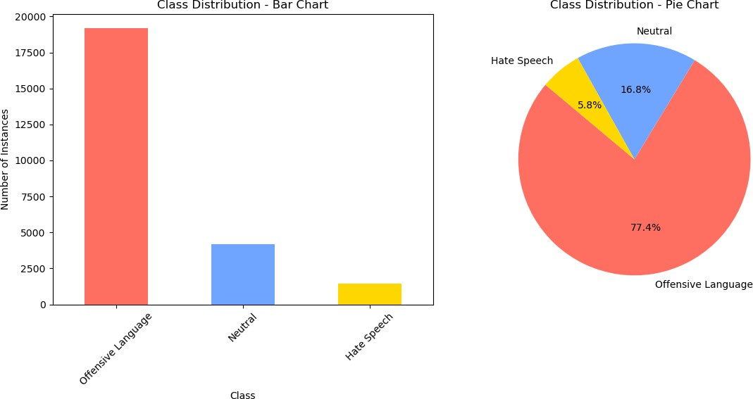

**Model Implementation and Evaluation**

**Text Vectorization**: The textual data was transformed into numerical features using Term Frequency-Inverse Document Frequency (TF-IDF) to prioritize unique terms while down-weighting common ones [2].

## Handling Data Imbalance:

* **Technique**: Synthetic Minority Oversampling Technique (SMOTE)
* **Reason**: Addressed class imbalance by oversampling minority classes to ensure better model performance.
* After applying SMOTE (Synthetic Minority Oversampling Technique), the dataset was balanced by generating synthetic samples for the minority classes (Neutral and Hate Speech) [5].

|  |  |
| --- | --- |
| Class | Number of Instances |
| Offensive Language (2) | 19,190 |
| Neutral (1) | 19,190 |
| Hate Speech (0) | 19,190 |

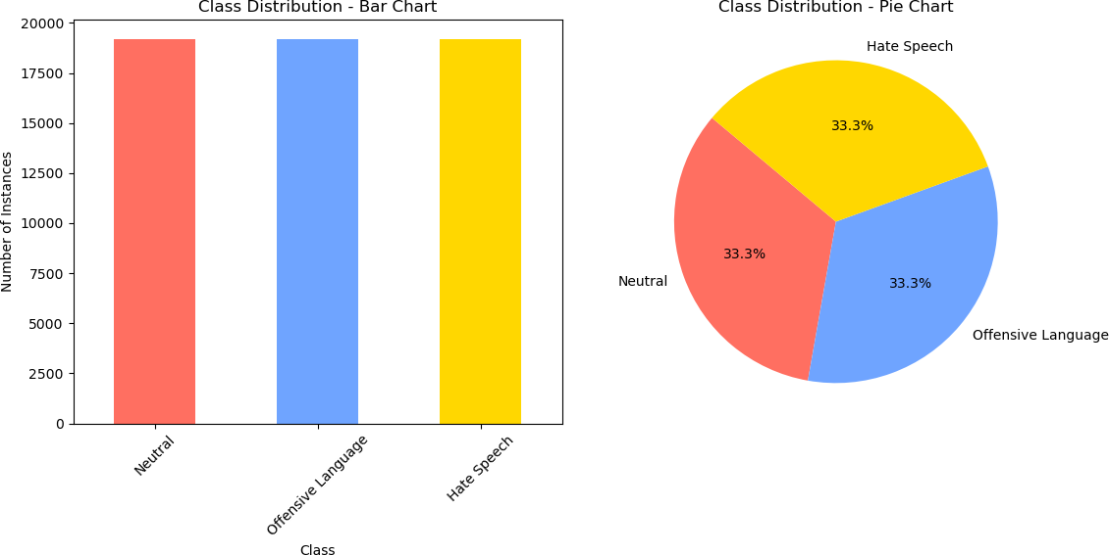

# Training and Testing

●Split the data into training and testing sets to evaluate model performance.

* **Proportion**: 80% training, 20% testing

## Hyperparameter Tuning

* Optimize model parameters for better performance.

**Model Selection**

**Machine Learning Models**

* + **Logistic Regression**: A linear model used for binary and multi-class classification problems. It predicts the probability that a given input belongs to a certain class [1].
  + **Support Vector Machines (SVM)**: A supervised learning algorithm that can be used for both classification and regression tasks. It finds the optimal hyperplane that maximizes the margin between different classes [4].
  + **Random Forest**: An ensemble learning method that combines multiple decision trees to produce a more accurate and stable prediction. Each tree is trained on a random subset of the data, and the final prediction is made by averaging the outputs of all trees (regression) or taking a majority vote (classification) [4].

**Model Evaluation**

|  |  |  |
| --- | --- | --- |
| **Model** | **Description** | **Accuracy** |
| Random Forest | A bagging ensemble method that uses decision trees. | 97.40% |
| Logistic Regression | A linear model for multi-class classification. | 94.56% |
| Support Vector Machine (SVM) | A kernel-based method with a linear kernel. | 96.12% |

# Conclusion

The project effectively tackled the challenge of hate speech detection using machine learning models. By preprocessing the data with techniques like TF-IDF for text vectorization and addressing class imbalance through SMOTE, the dataset was transformed into a balanced and representative format suitable for training robust models.

Among the three machine learning models evaluated, Random Forest achieved the highest accuracy of 97.40%, showcasing its strength in handling multi-class classification tasks. Support Vector Machine (SVM) and Logistic Regression also performed well, with accuracies of 96.12% and 94.56%, respectively, highlighting their potential in hate speech detection tasks.

The systematic approach to hyperparameter tuning and performance evaluation ensured that the models were optimized and validated effectively. This study demonstrates the potential of leveraging machine learning for hate speech detection, providing a solid foundation for developing automated systems to identify and mitigate harmful online content.

Future work could involve exploring deep learning techniques, incorporating contextual embeddings, and enhancing generalization through advanced data augmentation strategies to further improve performance and scalability.

# References

* [1] Bird, S., Klein, E., & Loper, E. (2009). *Natural Language Processing with Python*. O’Reilly Media, Inc.
* [2] Manning, C. D., Raghavan, P., & Schütze, H. (2008). *Introduction to Information Retrieval*. Cambridge University Press.
* [3] Porter, M. F. (1980). "An Algorithm for Suffix Stripping." *Program*, 14(3), 130-137.
* [4] Norvig, P. (2009). *Beautiful Data*. O'Reilly Media, Inc.
* [5] Chawla, N. V., Bowyer, K. W., Hall, L. O., & Kegelmeyer, W. P. (2002). "SMOTE: Synthetic Minority Over-sampling Technique." *Journal of Artificial Intelligence Research*, 16, 321-357.